Project: INTEGRATED THERAPEUTIC ARTS AND SOCIAL EMOTIONAL LEARNING FOR CHILDREN AND YOUTHS IN ZONE 1 BIDIBIDI REFUGEE SETTLEMENT
Project goal: Reduced suffering and improved mental health and psychosocial well-being among 40 children below the age of 18 and 70 youths between 18-25years,10 teachers and 10 community-based para counselors in Zone 1-Twajiji Village Bidi bidi Refugee Settlement Northern Uganda
Reporting period | September 2023
Compiled by: | Owino Paul |  |  | Reviewed by: |  |  | Mukasa Moses
Submitted To Donor | Global Alliance for Africa
Target: Children and youths, School teachers and Para counsellors |  |  |  |  |  |  |  |  | Project location: Twajiji Village, Bidibidi Settlement West Nile
Summary of Project background:
Uganda hosts up to 41% of the 2.3 million people displaced by South Sudan’s long-running civil war with at least 272,206 hosted in the Bidi bidi refugee settlement. children make 68% of the total population according to (Source OPM RIMs). This settlement is subdivided into 5 zones of 1,2,3,4 & 5 with most of the refugees originating from South Sudan. Displacement has cut short the education of many, restricted their livelihood options, and uprooted them from traditional socio-cultural roles in their communities. Youth, accordingly, suffer from inexperience and disillusionment to which high suicide rates are a testament. UNHCR (2021) reports accentuate that 65% of children in Bidi bidi have experienced physical violence 15% reported emotional violence well as 96% of both children and adults self-reported the existence of distress among children. (35%) attributed it to lack of food, 23% to separation from families, (38%) to staying in a bushy environment and restriction to play in one area and lack of play items. With youth and distressed children opt for negative coping strategies such as alcoholism and substance abuse, engaging in violent and gang fights, stealing and robbery, and early marriages among others. Through this project, TWSB promotes and strengthen capacities within the community through a GAA adapted therapeutic arts in its community based psychosocial support work to promote coping and psychosocial wellbeing including through outcomes and processes associated with social emotional learning framework (SEL) being implemented in target with children, youths, teachers and community-based para-counsellors within zone 1 of Bidibidi refugee settlement.

Planned project activities in the month (Coded as in the Work plan) |  | Target: (As in W/P) | Achieved |  | Cumulative | Variance |  | Comments on the results (under/over achievement), process and possible outcomes
Result/objective 1100: Social-emotional learning and psychosocial well-being of children and youths are improved through integrated therapeutic arts and community based psychosocial
Obj/Phase 1(TBD)- |  | Increased awareness and visibility of the project goal, objectives, and envisioned outcomes through organized inception meetings, workshops, and presentations in the online MHPSS working group meetings both national and onsite
1113 – Selected teachers trained in Social Emotional learning (SEL) |  | Following the acquisition of knowledge, skills, and attitudes to develop healthy identities, previously trained teachers have developed the ability manage not only their emotions but also those of their learners. They have felt and shown empathy for colleagues and supervisors, provided basic emotional support to the targeted participants/beneficiaries.  Furthermore, they have made relevant internal and external referrals that range from child protection related concerns including neglect, family separation, alcoholism, unaccompanied children to emotional and psychological problems. Several of the referred psychological cases have indicated situational depression, psychological distress and conduct disorders.
1113 – Para Counsellors trained in Community Based Psychosocial Support (CBPS) |  | The previously trained Para counselors have portrayed high level abilities to identify and mobilize children and youth that symptomize psychological challenges. While as they exercise this practice, they have as well been able to basic counselling skills to the targeted beneficiaries by providing not only Psychological First Aid (PFA), but also refer the beneficiaries to available service providers in emergency situations.  They have further supported in community awareness and psychoeducation sessions as they provide relevant support in mobilization, translation, co-facilitation and supervisory roles in peer-to-peer education.  This has resulted into positive change among the youths, constructive resilience, leadership and problem solving. Furthermore, it has enlightened a proper continuity aspect that will see transformation in the aftermath of the project closure.  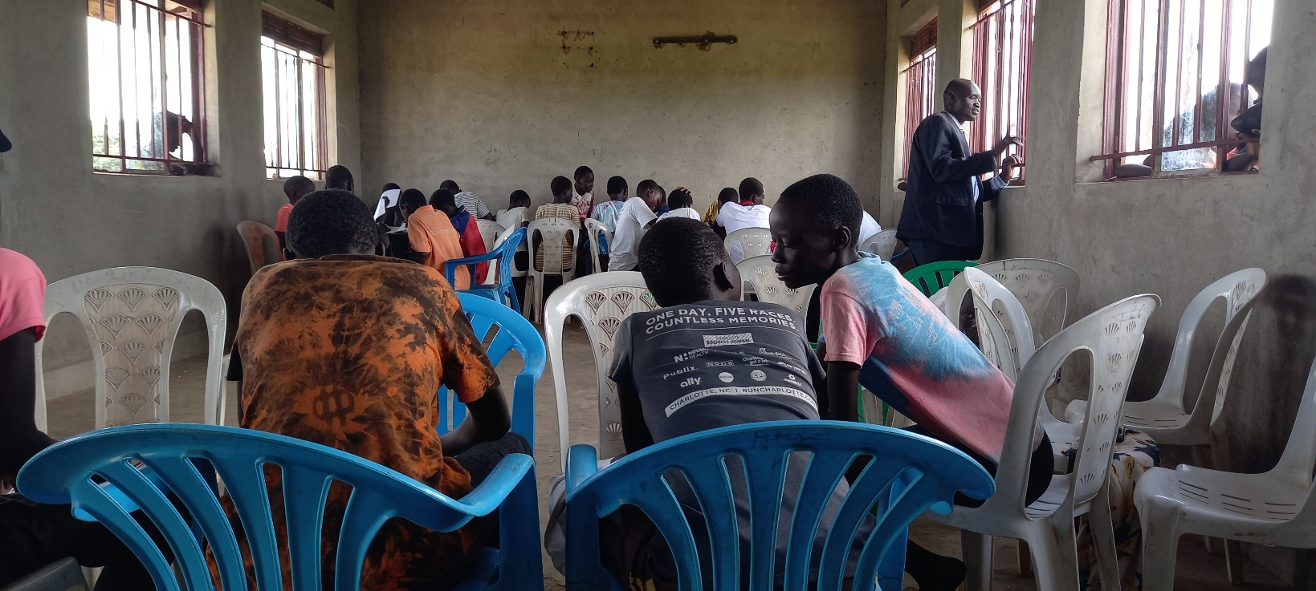  Fig 1: Para counsellors facilitating and awareness session
Result/objective 1101 Objective/Phase 2: Increased Abilities of targeted children and youth to cope with social, emotional, and psychological problems through, participating in expressive arts, dance storytelling, stress management skills, conflict management skills, problem-solving skills, , and knowledge of where to seek help or information and resources needed to access care
- identification of project participants through school head teachers, community-based para counsellors, community leaders, and educational partners conducted.  - An integrated five (5) social and emotional learning framework through Community based and arts program is rolled out across the targeted schools and selected 2 blocks in twajiji village |  | As part of the preparatory stages for the sessions, participants underwent mental health assessments where different disorders were assessed for, including depression, PTSD, anxiety, conduct disorders and Tourette Syndrome. The assessment indicated a high level of depression amongst children and youths and contributed to by the ongoing changes in service provision within the community, most of which is food reduction.  There’s also been a significant relationship between family separation and psychological challenges, where children that have separated from/with their initial families have indicated high levels of distress and are struggling to cope with the unending challenges they face. This has also impacted their education levels, affecting their levels of concentration both in and out of class, contributed towards sleep challenges and uncontrolled worriedness.  The intended target of 40 children has been achieved and grouped into three (3), with an intention to enhance realistic changes and recovery.  Group name Male Female Total  Melody 06 07 13  Bright star 06 08 14  Joy of salvation 09 04 13  Total 21 19 40  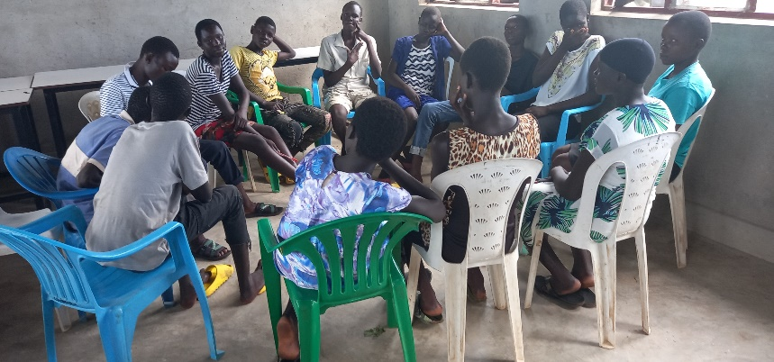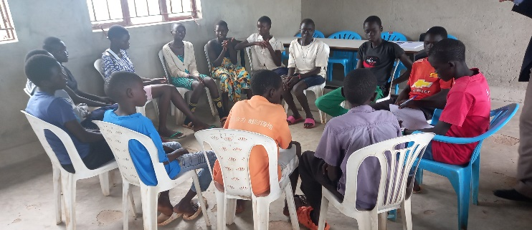  Fig 2 & 3: Participants converge within their respective groups for the artistic session  The artistic sessions focused on helping the children at risk realize their dreams and potentials, hold onto a resilient attitude, exhibit emotional balance and management, improve their concentration levels and be more productive within their schools and communities.  During sessions, 1Female learner reports psychological distress as a result of domestic violence between the parents. 14 learners report being engaged in farming by the parents to benefit from the rainy season.  Furthermore, learners present with optimism towards issues they are facing in the present. Learners report deterioration in self-reported symptoms that affect their psychological wellbeing. Learners are also able to define their own dreams and what they want in life. Improvement in mood and behavioural regulation has been closely observed among learners.
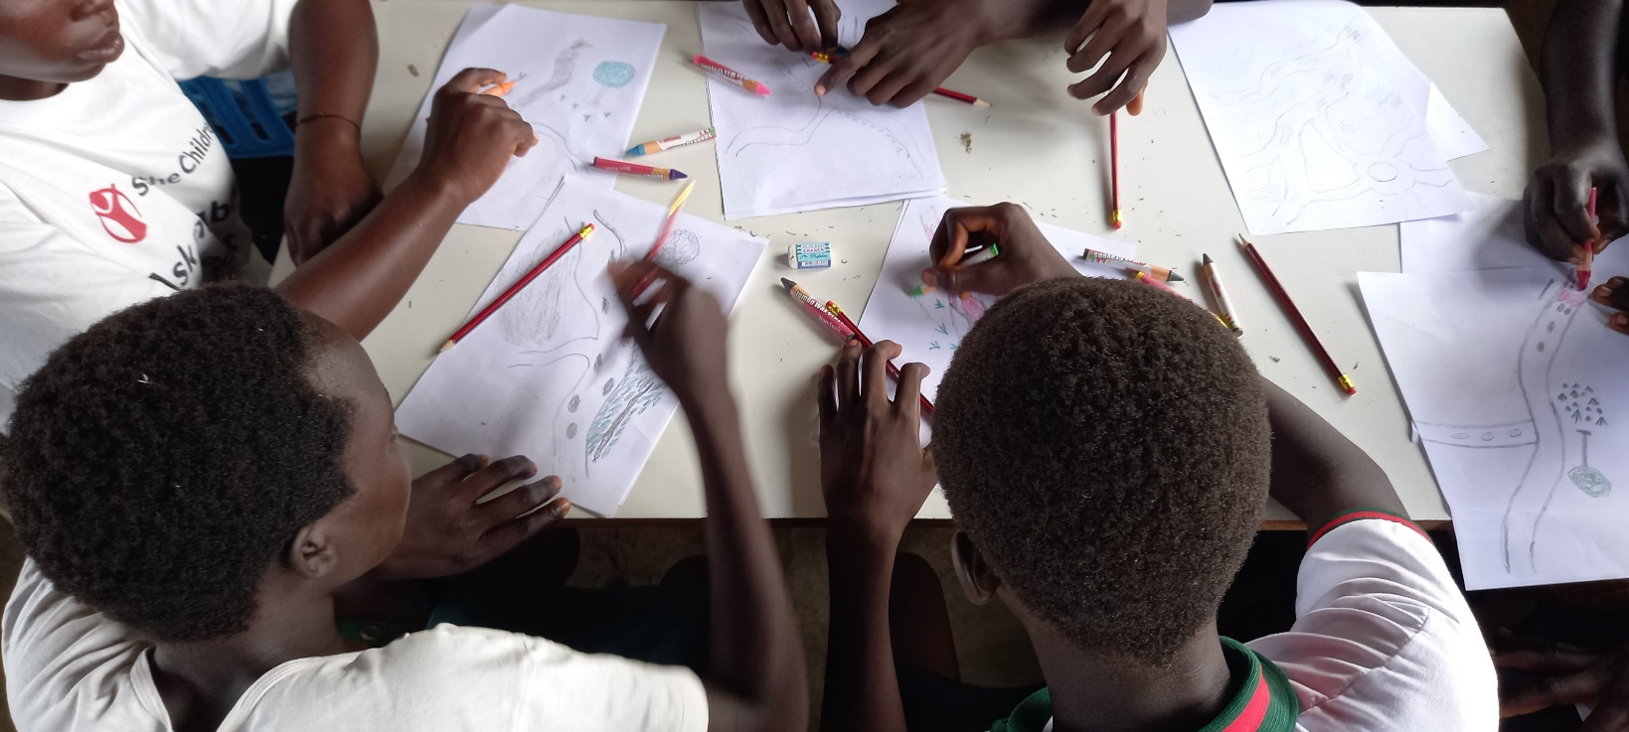

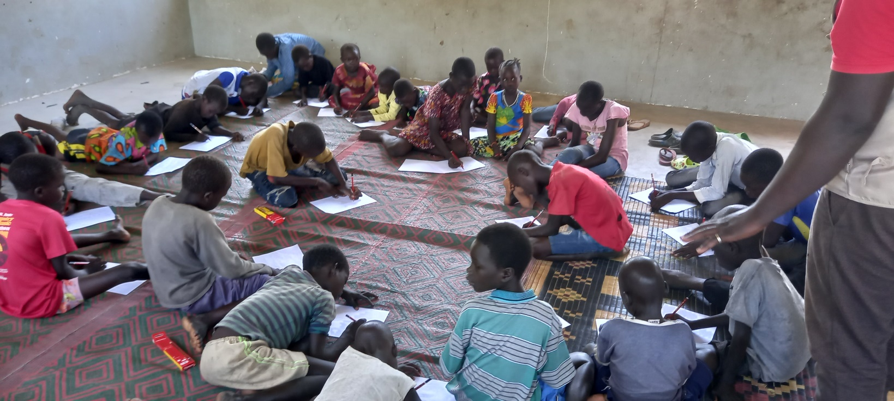
Fig 4 & 5: Learning through art/drawing

Similarly, 70 (M-, F-) have been reached through artistic sessions with inclusiveness of other therapies like narrative exposure and cognitive behavioral therapy. The beneficiaries are as broken-down below;
Group name | Male | Female | Total
Academic | 08 | 13 | 21
United | 14 | 05 | 19
Peace | 06 | 09 | 15
Surprise | 04 | 11 | 15
Total | 32 | 37 | 70
These included 4 child mothers, 1 male with a physical disability, 38 school going and 27 drop outs.
The youths portrayed significant willingness and understanding of psychosocial support, building resilience, problem solving and description of their challenges. They also showed interest in sports and drama activities which can keep them engaged and help them fill the gaps into mental health within their families and communities.
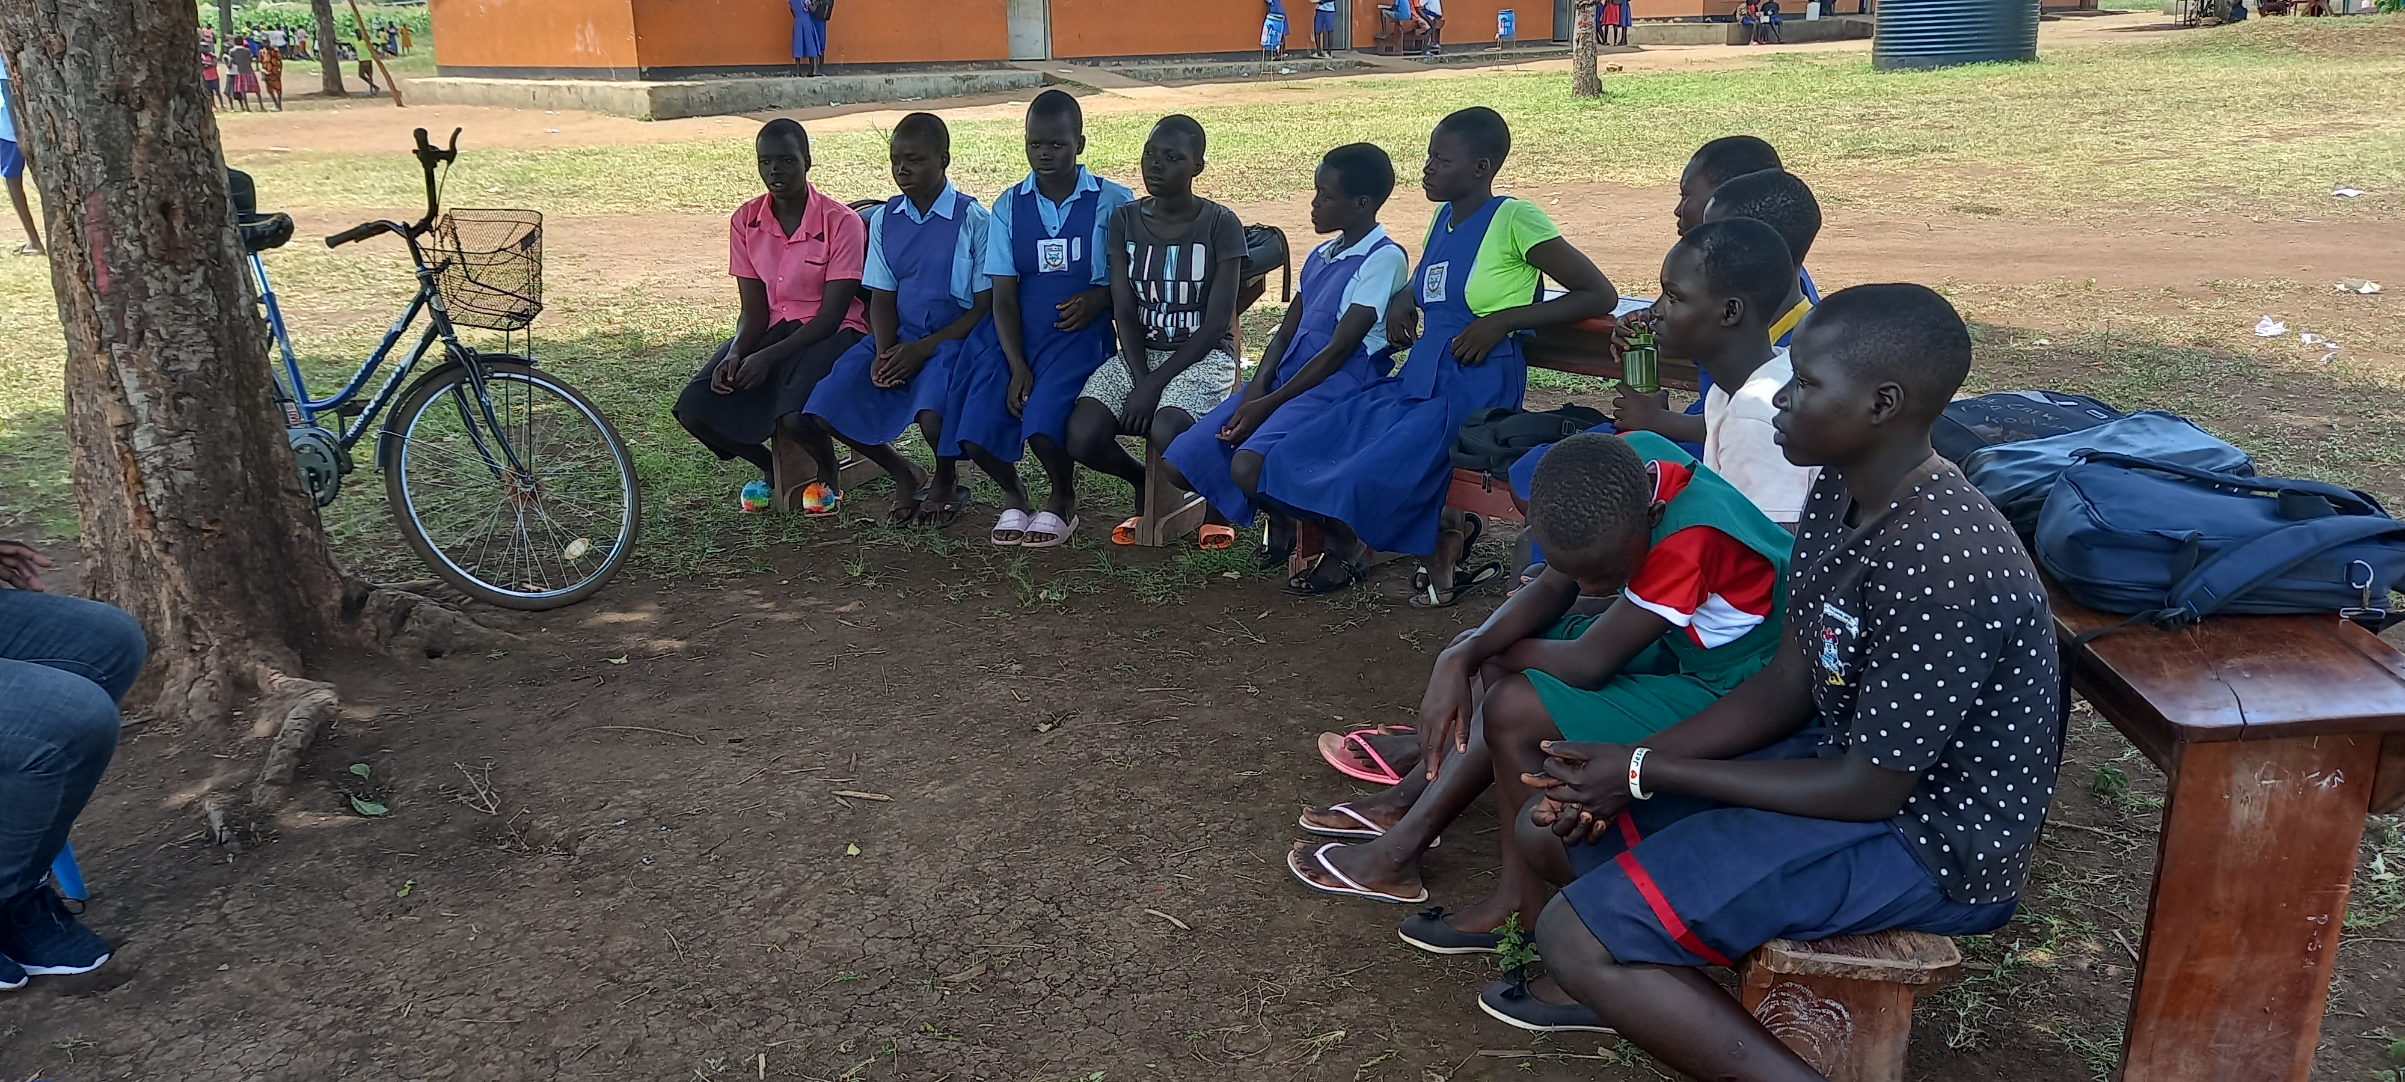
Fig 6: Selected youths group engaging into session dynamics
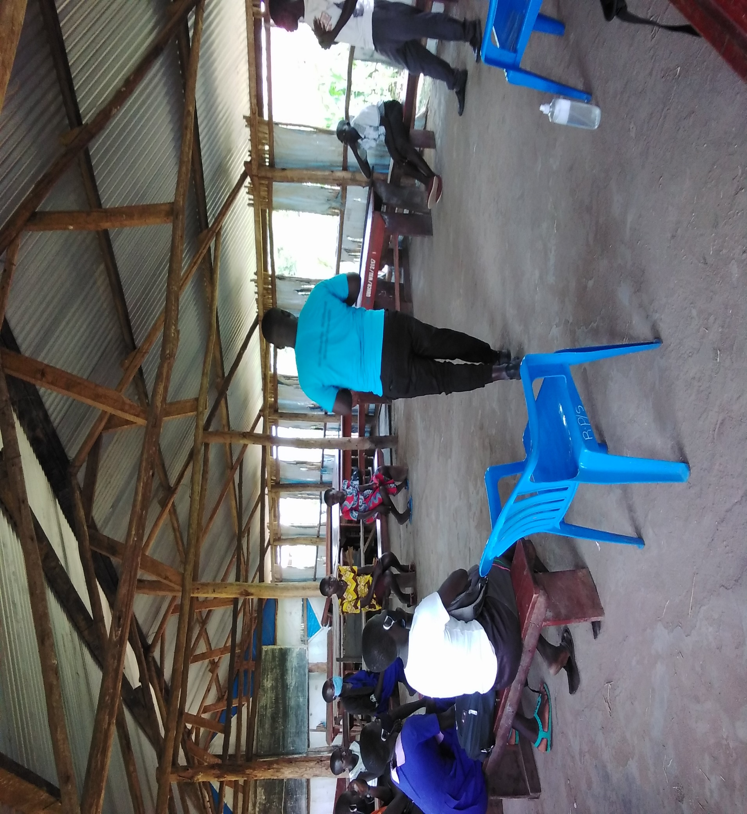
Fig 7: Relaxation and meditation

